# DISTRIBUTED SYSTEMS LAB

## ADVANCED APPLICATION MODELING

### Role-based Access Control (RBAC)

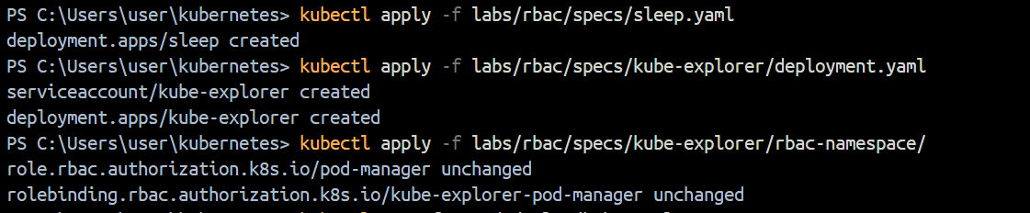

### DaemonSets

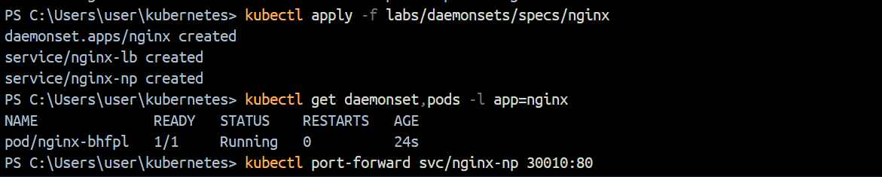

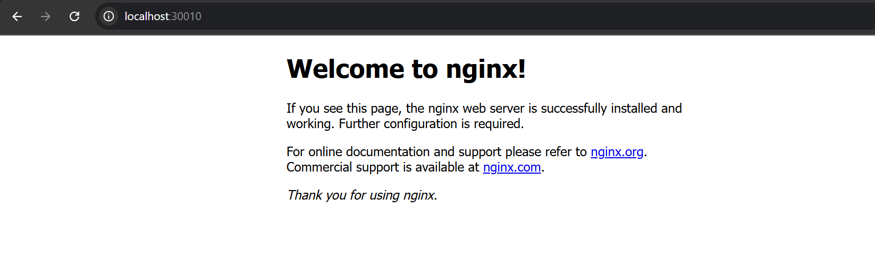

### Ingress

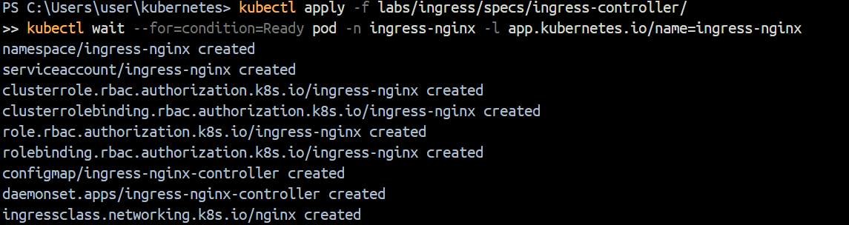

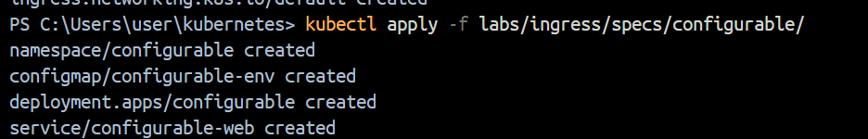

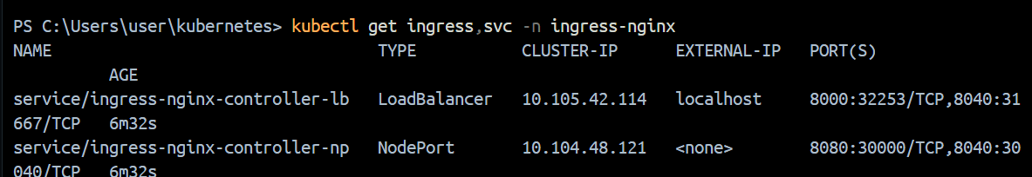

### Jobs and CronJobs

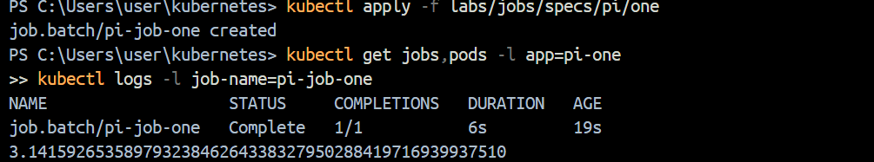

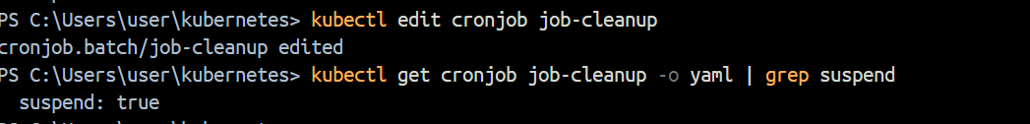

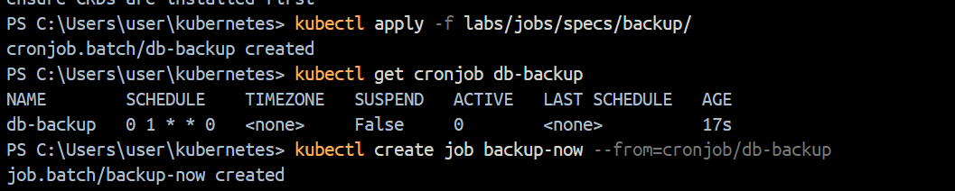



### StatefulSets



